2026 Paw Paw Hawg Hunters
Tournament Schedule
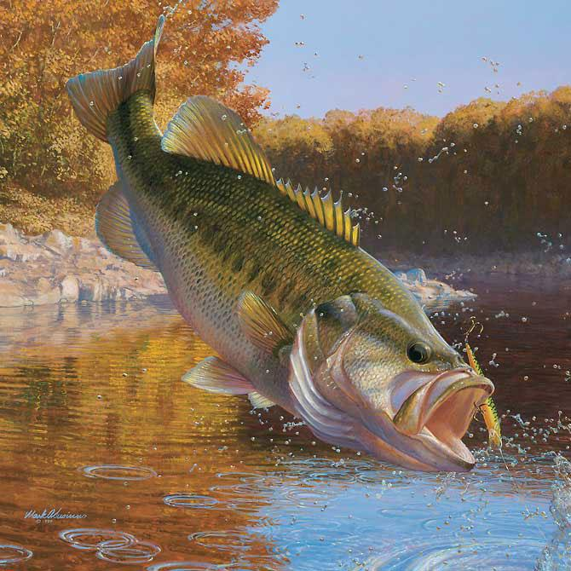
Tournaments will begin 5:30 P.M. and end at 9:30 P.M. Tournaments will end at 9:00 P.M. beginning with 8/6 Tournament
Classic will be from 7:00 AM to 2:00 PM

PAYOUTS (Based on 15 boats)

1st Place - $230 2nd Place - $130 3rd Place - $90 Big Bass - $90

Directors

Mark Wolownik 271-2582 Eric Nitz 806-6502 Steve Wolownik 720-7601

DATE
May 28
June 4
June 11
June 18
June 25
July 2
July 9
July 16
July 23
July 30
Aug 6 (Weigh-in 9:00)
Aug 13 (Weigh-in 9:00)
Aug 20 (Weigh-in 9:00)
Aug 26 (Wed.) (Weigh-in 9:00)
Sept 3 (Weigh-in 9:00)
Sept 9 (Wed.) (Weigh-in 9:00)
September 12 (Sat) Classic

LAKE
Kalamazoo River
Pipestone Lake
Paw Paw Lake
Stump Bay
Cloverdale Lake
Saddle Lake
Austin Lake
Magician Lake
Gull Lake
Fish/Finch/Saddlebag
Lake Allegan
Portage Lake
Saddle Lake
Maple Lake
Austin Lake
Magician Lake
Paw Paw Lake

ACCESS
Douglas – Schultz Park
Sister Lakes
Watervliet - West
Three Rivers
Hope Twp Park
Breedsville
Portage
Sister Lakes
Richland
Marcellus
Allegan – Monroe Rd
Schoolcraft
Breedsville
Paw Paw
Portage
Sister Lakes
Watervliet - West

