2026 PAW PAW HAWG HUNTERS APPLICATION
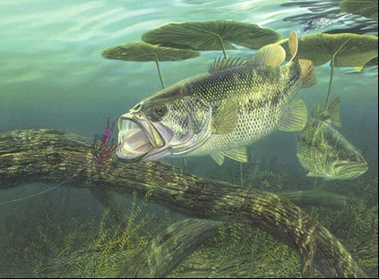
I have read the tournament rules and understand them. I agree that Paw Paw Hawg Hunters, or any of their members will not be held responsible or liable for any accident, injury, death, or damage which may occur during, on my way to, or on my way home from any of their tournaments.
Boat owners name: ____________________________________________
Address:___________ ____________________________________________________________
City:___________________ _____________________Zip:_______ ________________________
Phone:_____________________Cell__ __________________ E-mail:________ _ __________
Partners Name:____________________________ _____________________________________
Address:___________________ ____________________________________________________
City:_________________ _______________________Zip__________________ ______________
Phone:_________ ____________Cell:____________ ___________E-mail:_______ ____________
Boat owner’s signature:________________________ _____________Date:____________________________
Partner’s signature:_________________ ______________________Date:_______________ __________

Membership fee: $130.00 per boat
Weekly Tournaments: $40.00 per boat

Please return signed application & membership fee ($130) as soon as possible. Club size will be limited to 15 boats. Membership will be on a first come/first served basis, with returning members having priority over new members. Every boat must pay weekly tournament fee ($40), whether they fish or not. Substitutes are allowed (1 per boat) but you must fish 5 tournaments and be a member to fish the classic.

Send applications to and make checks payable to: Mark Wolownik
110 North Harris Street
Paw Paw, MI 49079

